**Practical-04**

**GitHub**

**What is GitHub?**



GitHub is a web-based Git repository hosting platform for version control and collaboration.

It lets you and others work together on projects from anywhere.

In other words, it's a place where every developer can share their source code and stories with the world.

It's a huge and highly respected collaboration platform, and it's used by just about every big technology company such as  [Googl](https://github.com/google)e,  [Twitte](https://github.com/twitter)r,  [Mozill](https://wiki.mozilla.org/Github)a,  [Faceboo](https://code.facebook.com/projects/)k,  [IB](http://ibm.github.io/)M,  [Netflix](http://netflix.github.io/), [Dropbo](https://github.com/dropbox)x, and  [PayPal](https://github.com/paypal) etc.

**Question 1: Set up your account on GitHub.**

Perform the following steps:

**Step 1: Set up a personal account**

Open the web browser and Visit the GitHub web site  [**https://GitHub.com**](https://github.com/)**/**

The following page will be displayed.\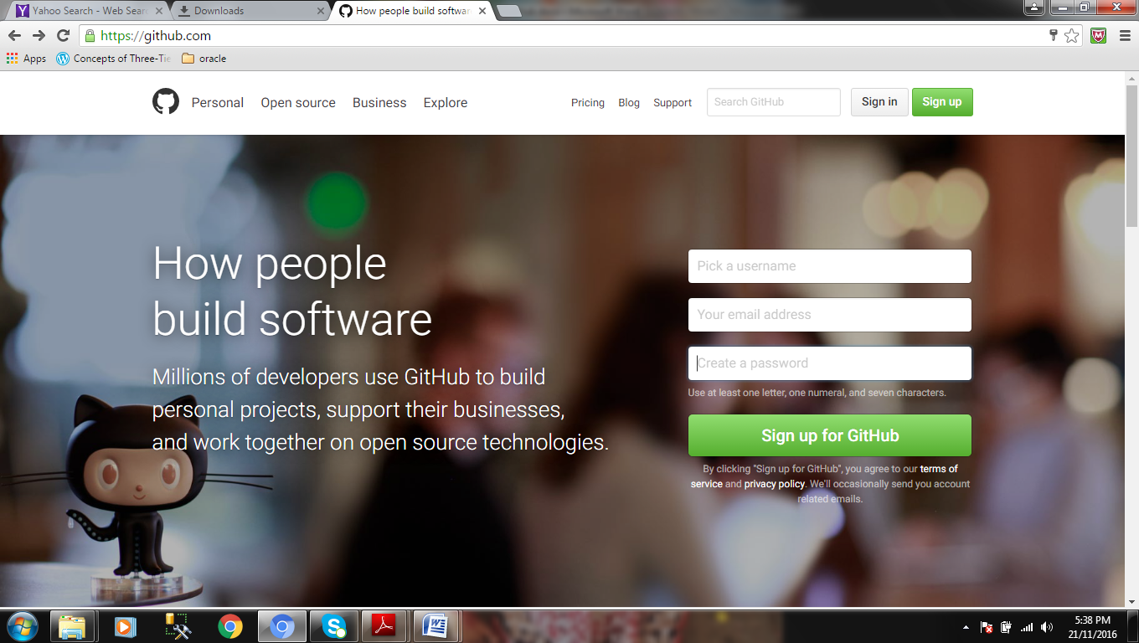

**To set up an account, enter the following details**

1. Choose a user name that isn’t already taken, valid email address, and password.
2. The user name should be alphanumeric and only hyphen is allowed.
3. The password you create must use at least one letter, one numeral, and seven characters.
4. Then click “Sign up for GitHub”.

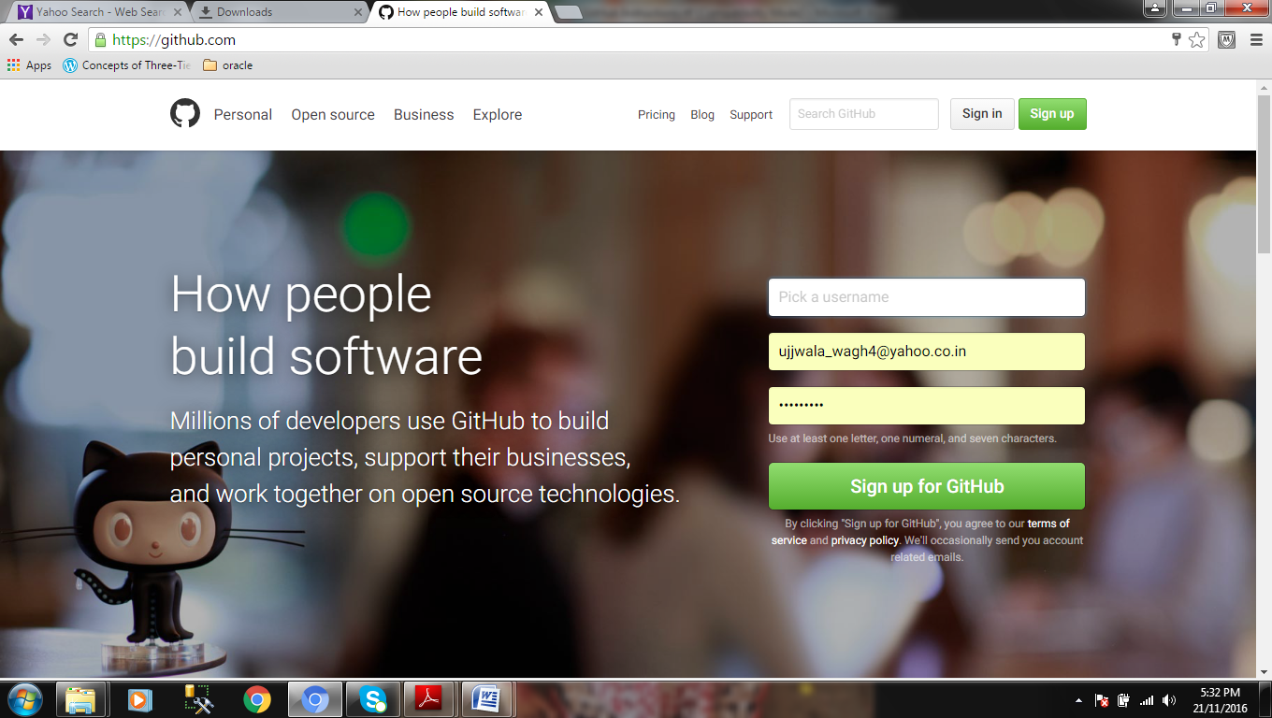

**Step 2: Choose your plan.**

After signing up, following page will be displayed.

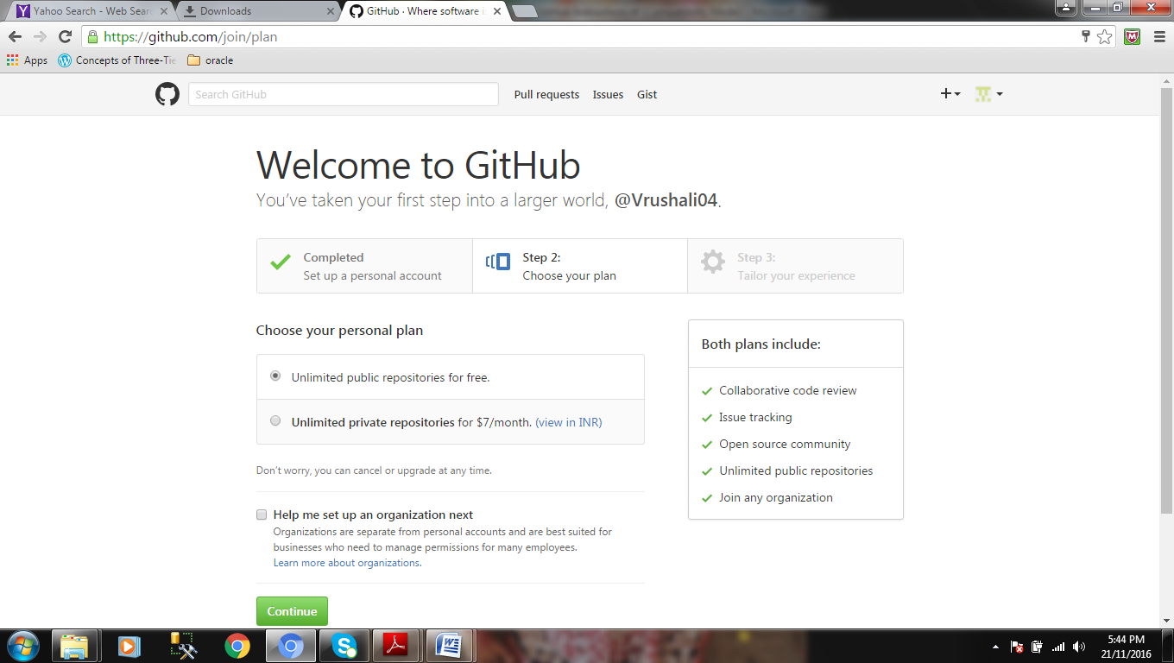

Select unlimited public repositories for free. And click on “Continue” button.

**Step 3: Tailor your experience**

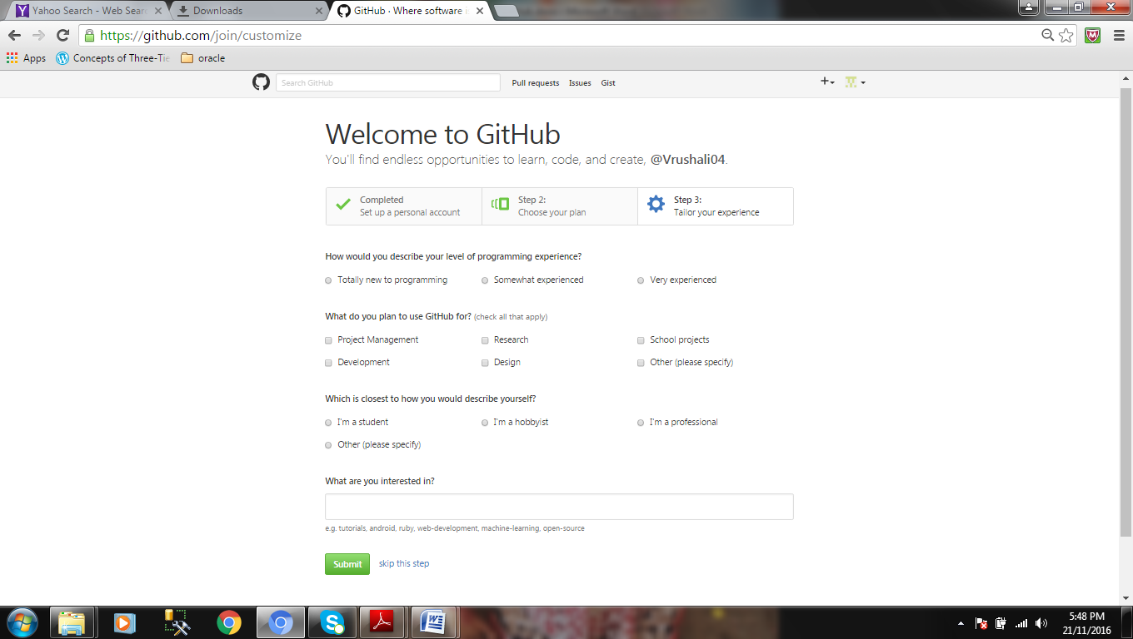You can either skip this step by clicking on Skip this step link at the bottom or select the options according to your choice and finally click on “Submit” button.

Following page will be displayed.

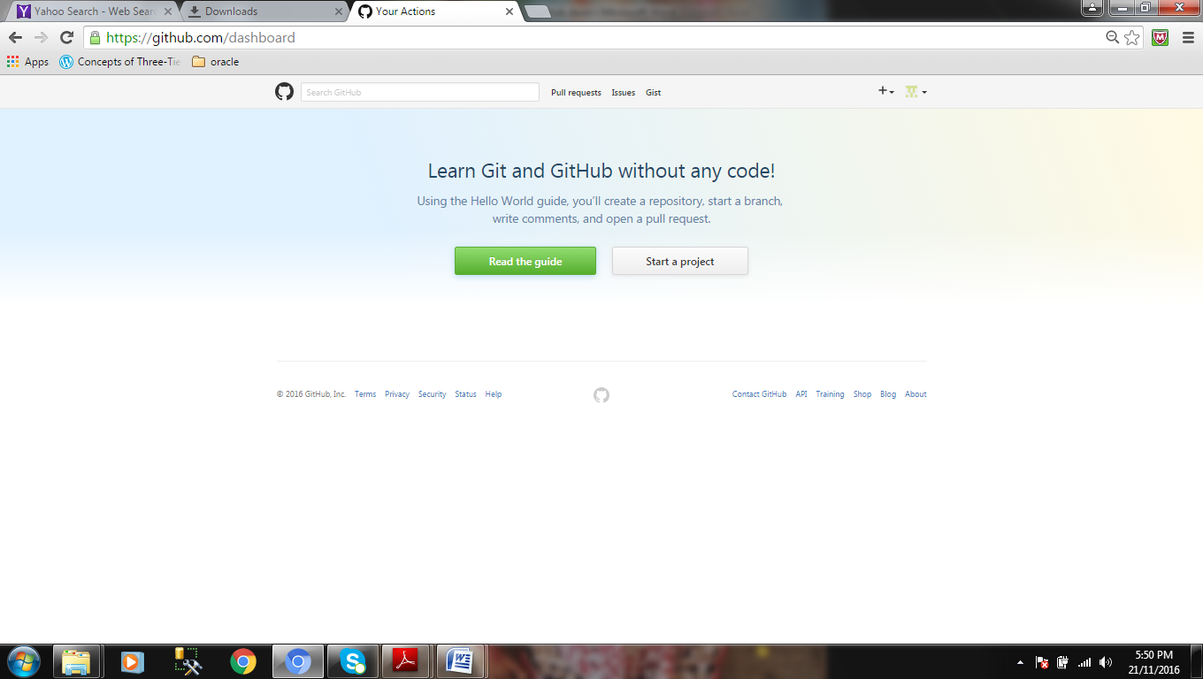

Now click on “Start a project”.

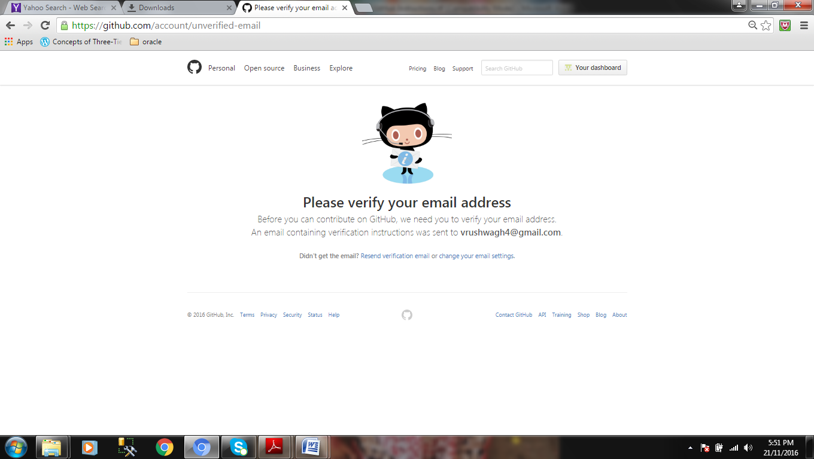

To verify your email address you have to sign–in to your email account which you have provided while setting up the GitHub account.

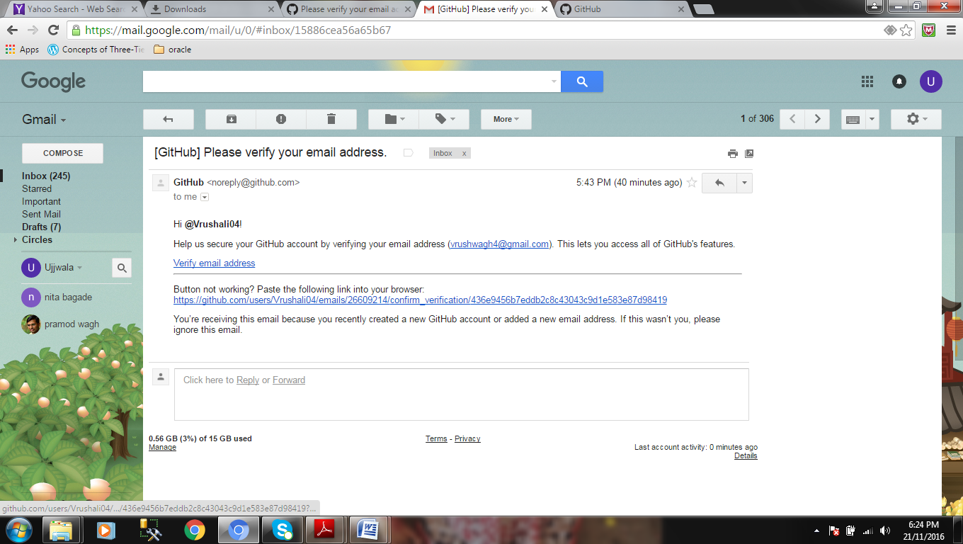

In the above screen, click on Verify email address link. You will be redirected to the following page. This page shows a message “**Your email was verified**.” Now, click the button – “Start a project”.

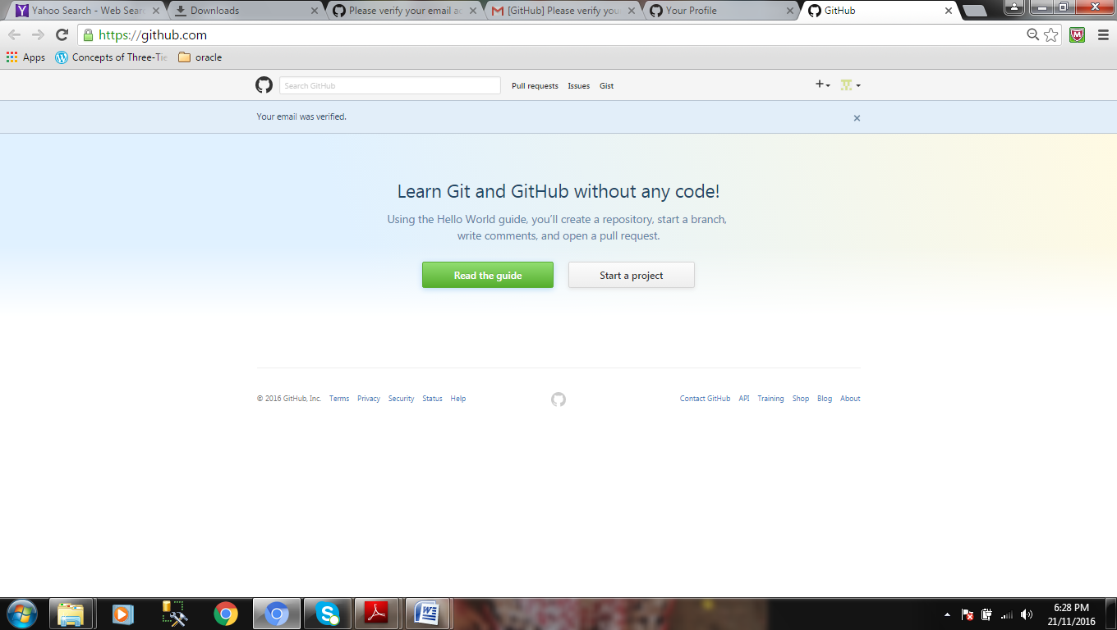

The following page lets you create a new repository. It shows your username as an owner of the repository.

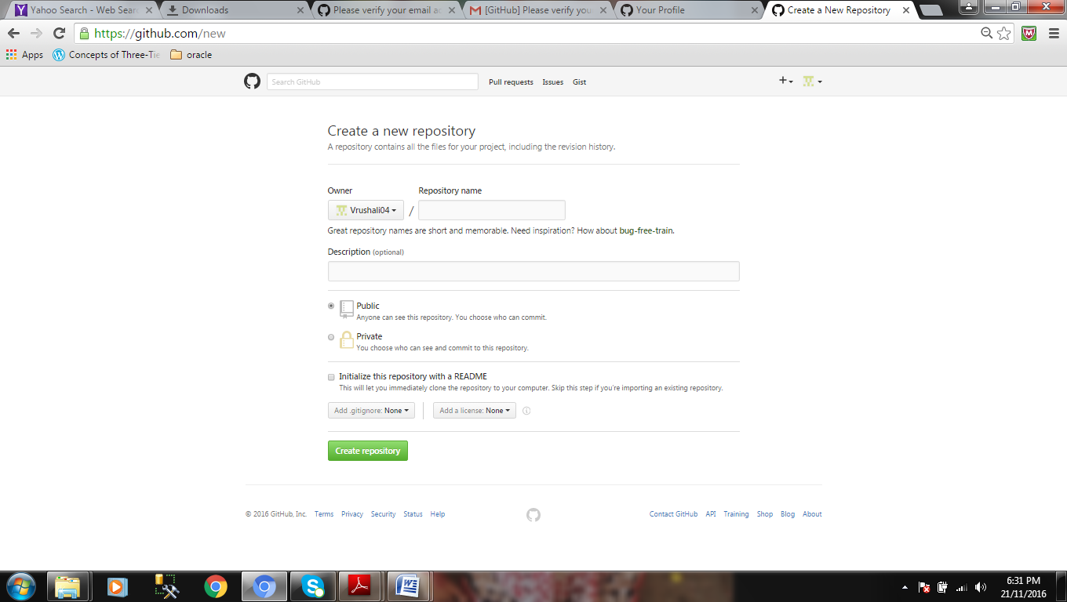

**Question 2: Make a group of two students & perform the following:**

**Student 1: Create a repository Source. Add Student 2 as a collaborator.**

Perform the following steps:

**Step 1: Create a new repository** 

A **repository** is usually used to organize a single project. Repositories can contain folders and files, images, videos, spreadsheets, and data sets – anything your project needs. We recommend including a *README*, or a file with information about your project. GitHub makes it easy to add one at the same time you create your new repository. It also offers other common options such as a license file.

Your **source** repository can be a place where you store ideas, resources, or even share and discuss things with others.

**To create a new repository**

Name your repository “source”.

Write a short description.



Select the option “initialize this repository with a README.”



Add a license: “GNU General Public License v3.0”

Then, click on “Create repository” button.

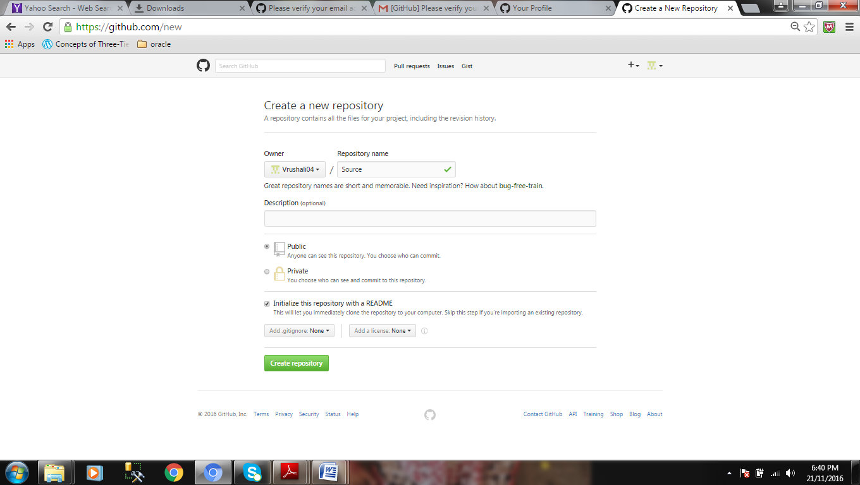

After creating repository, the following page will be displayed.

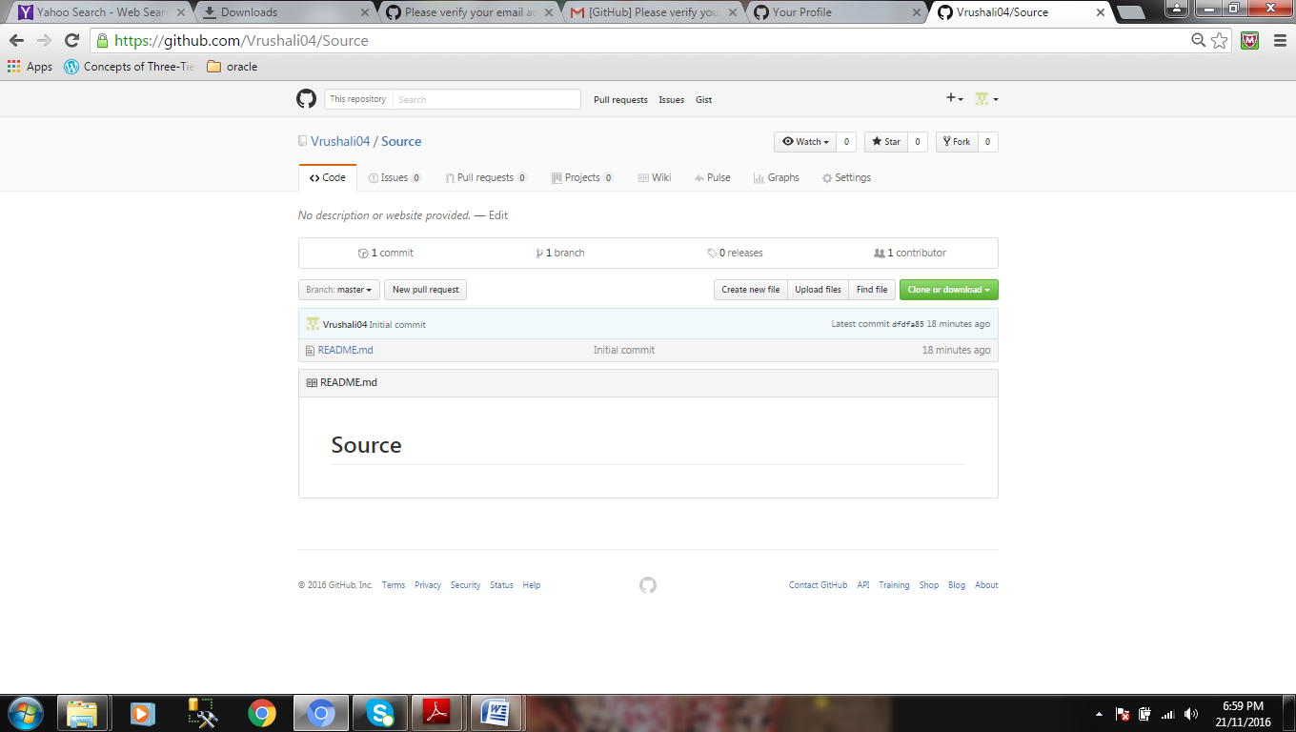

By default your repository has one branch named master which is considered to be the definitive branch. We use branches to experiment and make edits before committing them to master. So, Branching is the way to work on different versions of a repository at one time.

**Step 2: Add Student 2 as a collaborator**

Click on Settings option as highlighted below.

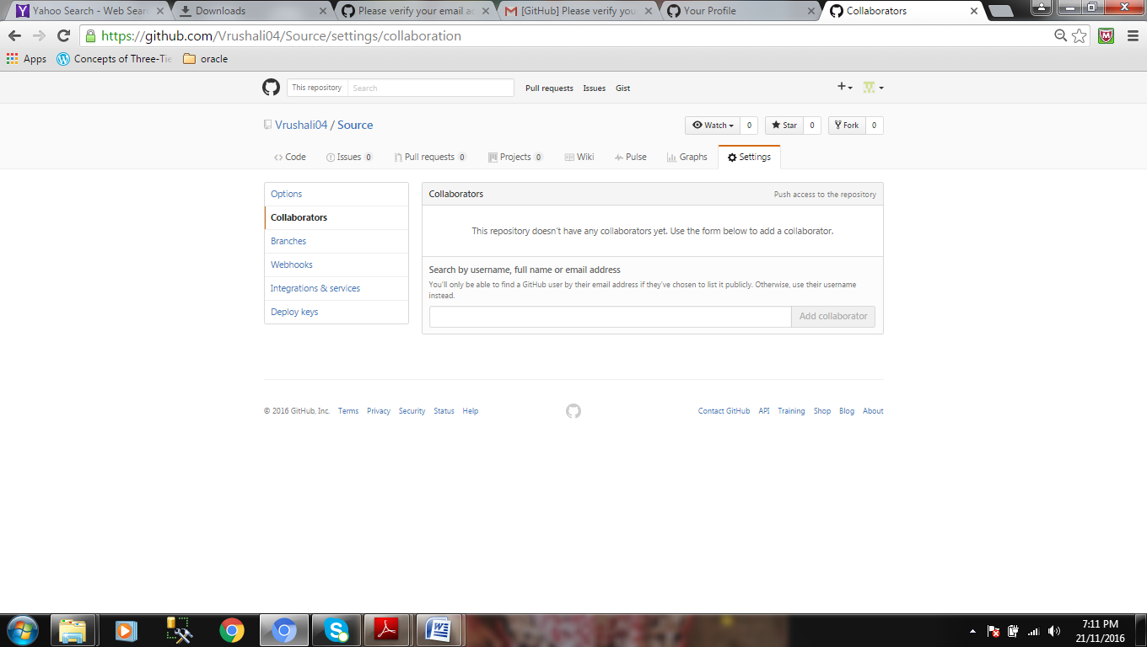

Type the username, full name or email address of Student 2 whom you want to make the collaborator in the search box.

After typing the name click on “Add Collaborator” button.

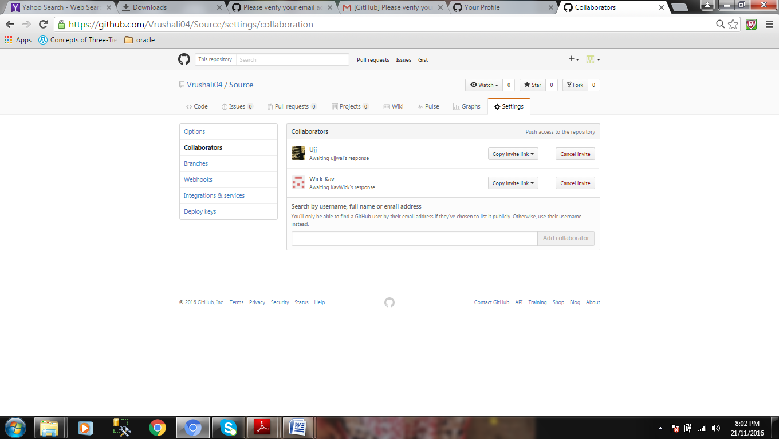

An invitation will be sent from Student 1 to Student 2.

Student 2 will accept the invitation by logging in its corresponding email account.

**Student 2: Clone the repository. Create a text file “Foods” that has your name & a favorite food. Commit & push your changes.**

**Step 1: Click on “clone or download” button to download your repository.**

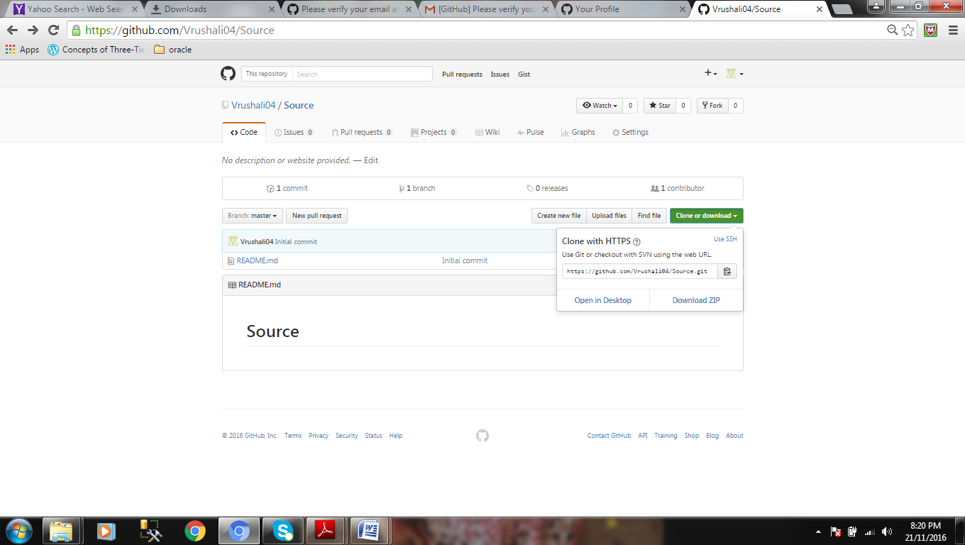

Click on “Download ZIP” option.

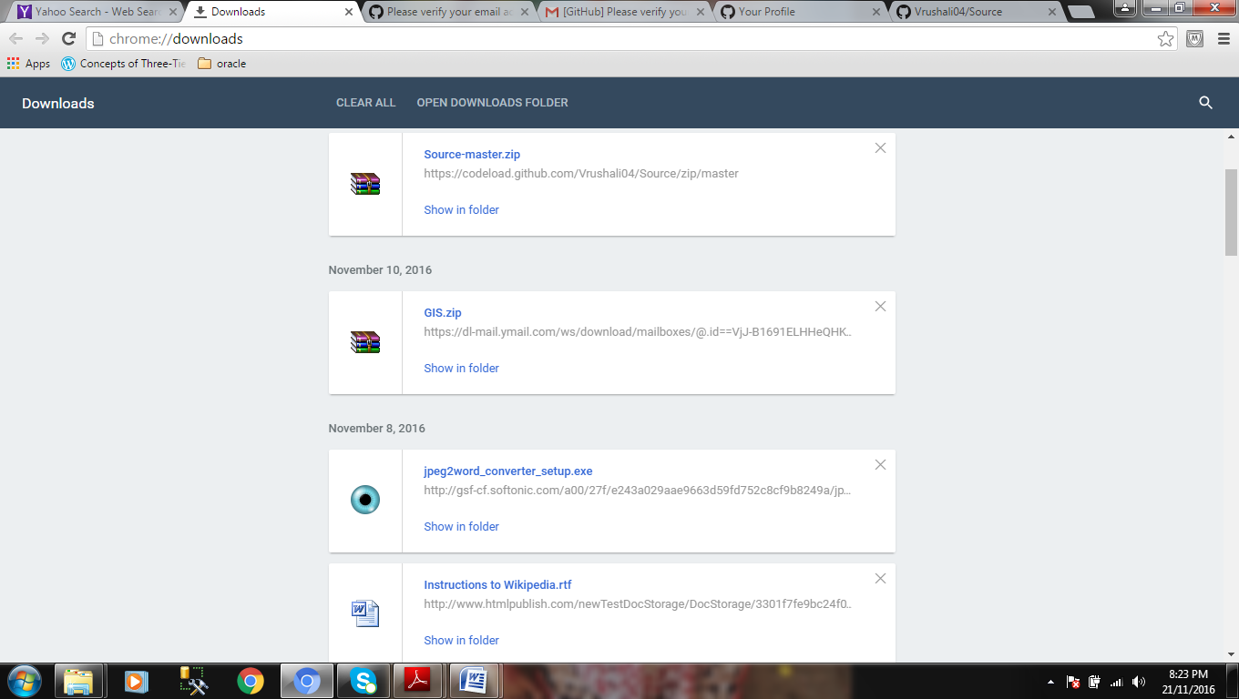

Your repository with master branch will be saved as zip file. Click Ok.

**Step 2: Create food.txt file**

Go to Downloads directory. And unzip the files. Now, inside favorite-master directory create a new text file as code. Add your name and class and semester.

Now click on “Upload files” button to upload code text file to source repository.

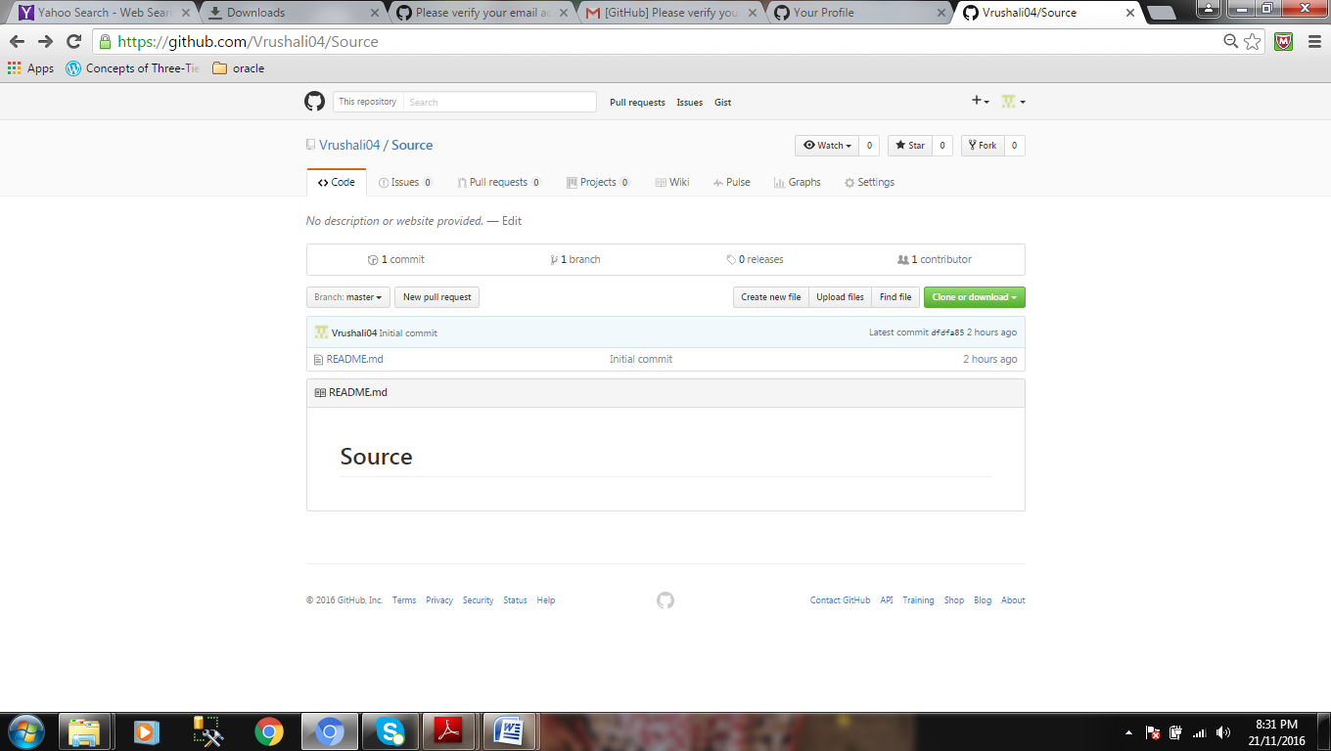

The following page will be displayed. You can either drag the file or click on choose your files link.

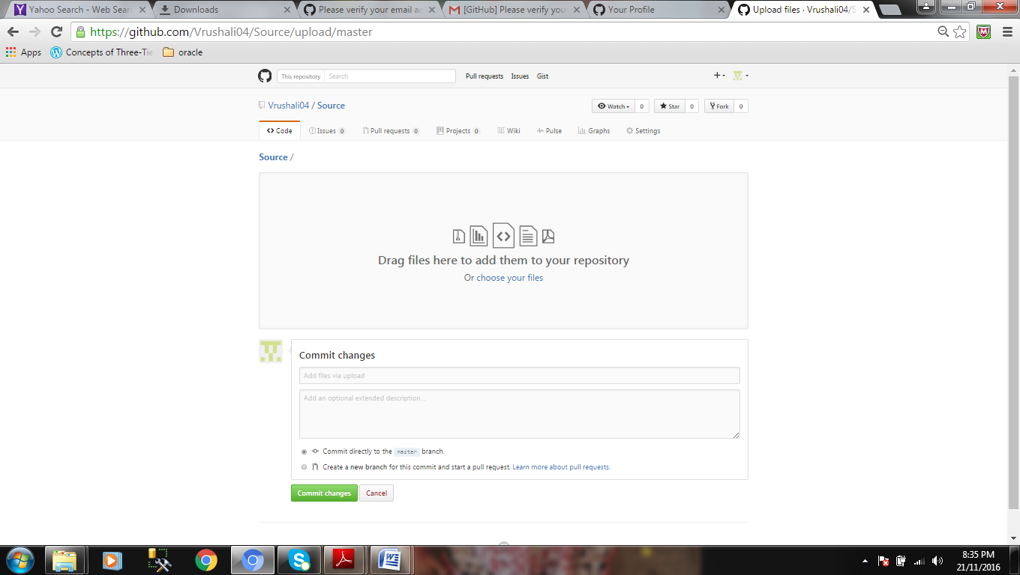

The following page shows code.txt file is uploaded.

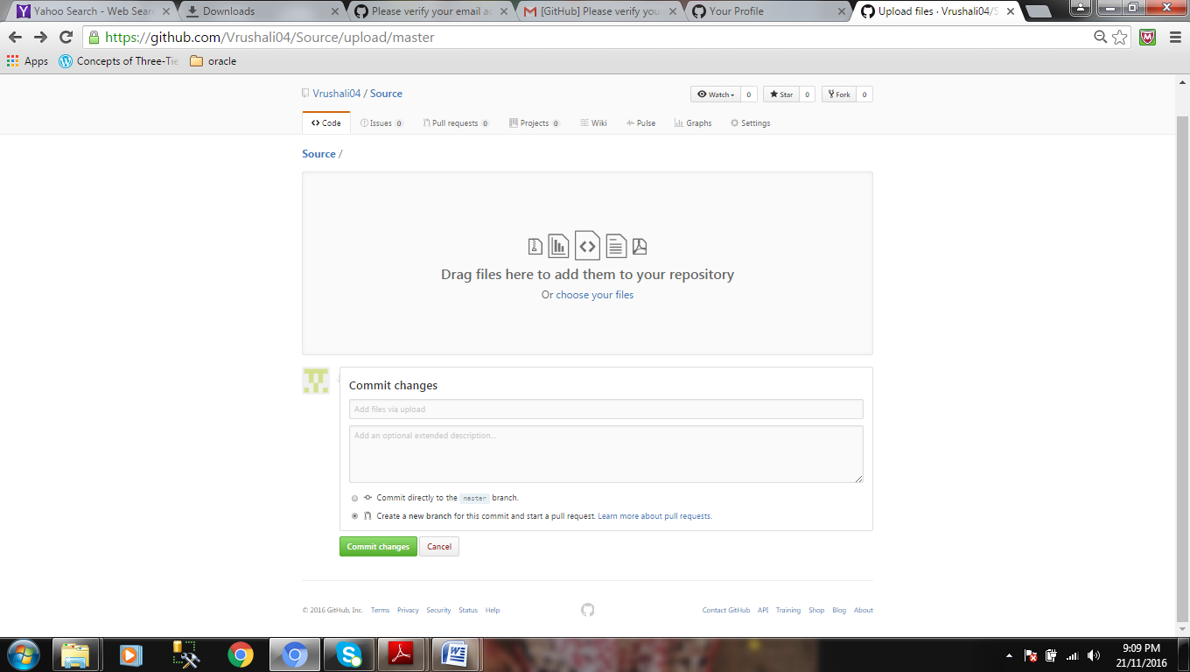

In commit changes section, set the title and description for commit.

You can either commit directly to the master branch or to the new branch.

Select option to create a new branch. And click the button “propose changes”

**Step 3: Commit, and push your changes**

Open a pull request page will be displayed.

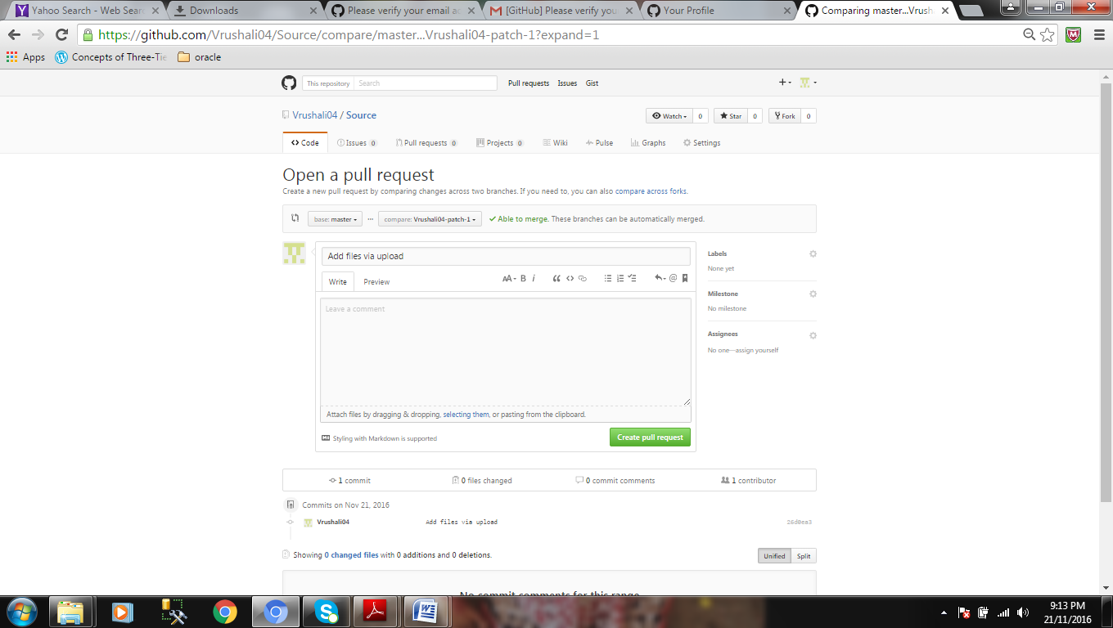

Click on “create pull request” button.

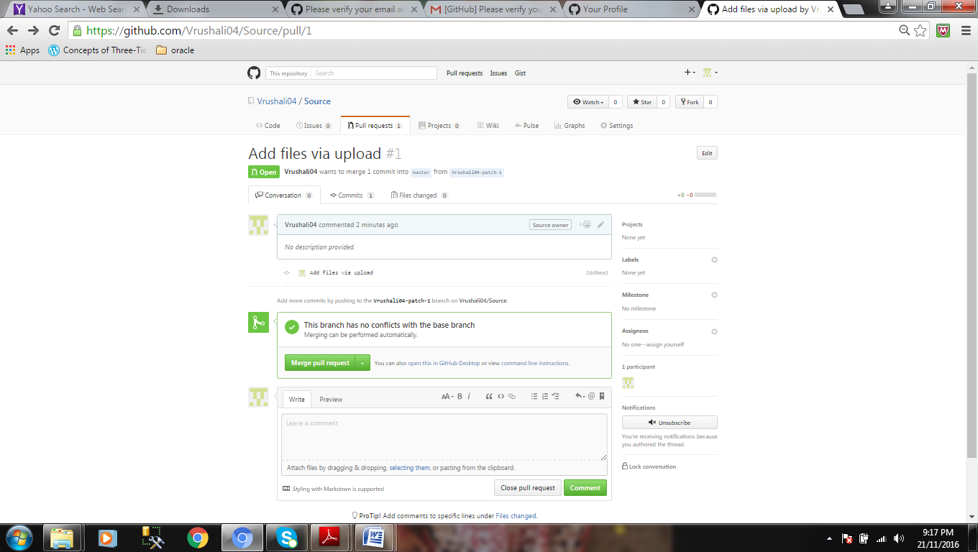

Click on “merge pull request” button

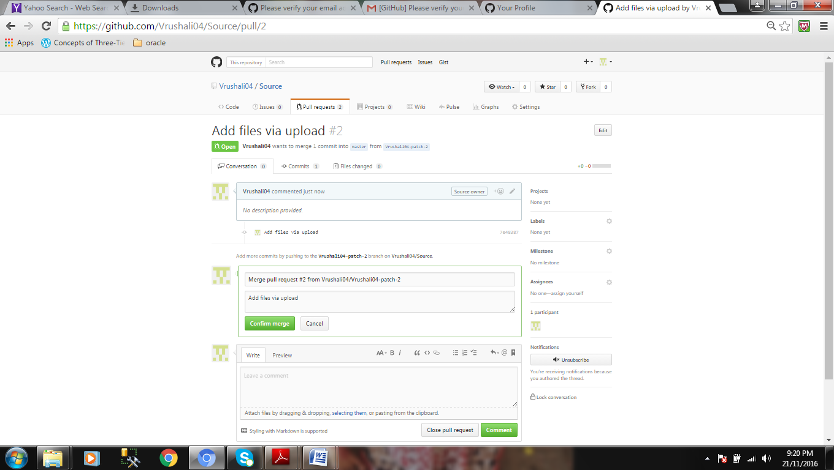

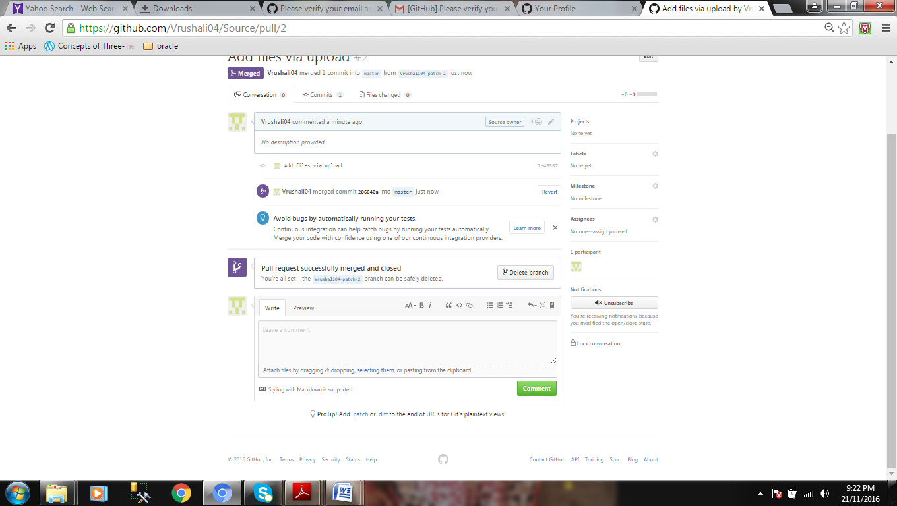

You will get a message “Pull request successfully merged and closed”.

Click on your repository name “favourite” to view the food file in your master branch

